POWER BI LAB - Factor Analysis with Key Influencers

LAB THEORY
Power BI has been utilizing machine learning to simplify complex tasks for their users in order to empower everyone in organizations to harness the power of AI to make better decisions.
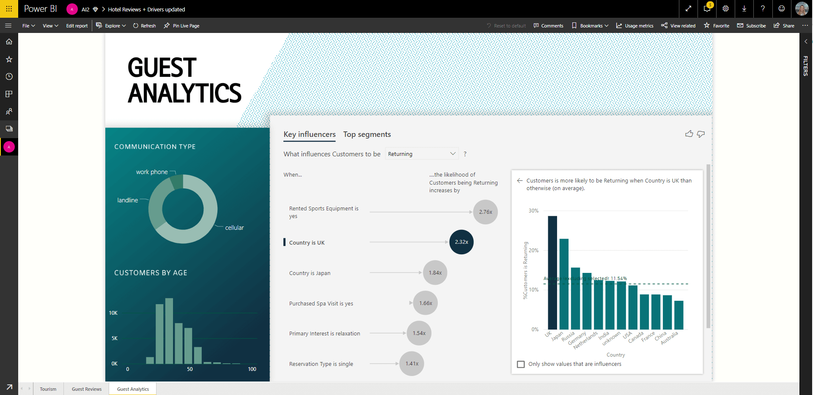

Business problem
For any business, identifying and understanding key influencers (the main drivers for business performance and outcomes) and customer segments is critical for making strategic business decisions, prioritizing changes to the business, and gaining competitive advantage. Analyzing key influencers can reveal which factors have the biggest impact on business performance and can help a business answer questions such as "which factors lead customers to leave negative reviews about this service?" or "what influences customers to have NSF (not sufficient funds) payments?"
However, this process of data analysis for key influencers and customer segmentation takes a lot of time, effort, and expertise; it often involves coding multiple functions, sampling, significance tests, and ranking results. Thus, Power BI turned to a machine learning solution so that they could enable their users to speed up the process of gaining meaningful insights and to be able to do statistical analysis without having to spend time writing complex code.

Key Influencers is a much simpler solution to coding
Power BI created the Key Influencers visualization as a machine learning solution to allow businesses to leverage AI so that they can analyze their data in less time and make key business decisions faster. In other words, users can use Key Influencers to spend less time analyzing data and spend more time acting on the insights gathered from the AI visualization.
Once a user picks a key performance indicator (KPI) to analyze (for example, retention rate, click-through rate, NSF payments), the Key Influencers visualization uses machine learning algorithms provided by ML.NET to figure out what matters the most in driving metrics, as well as to find interesting segments for further investigation. Key Influencers analyzes a user's data, ranks the factors that matter, contrasts the relative importance of these factors, and displays them as key influencers and top segments for both categorical and continuous variables.

Solution architecture
The Key Influencers visualization is supported in the mobile, desktop, shared service, and premium service forms. When a user adds columns to the Key Influencer visual, a flow is triggered in which training data is sent to Analysis Services (the database engine behind Power BI). Analysis Services runs ML.NET to train machine learning models, and results are returned. Thus, the model is trained whenever a user updates selected features. The overall goal is to perform the analysis in a few seconds, enabling an interactive experience.

The overall flow is shown below:
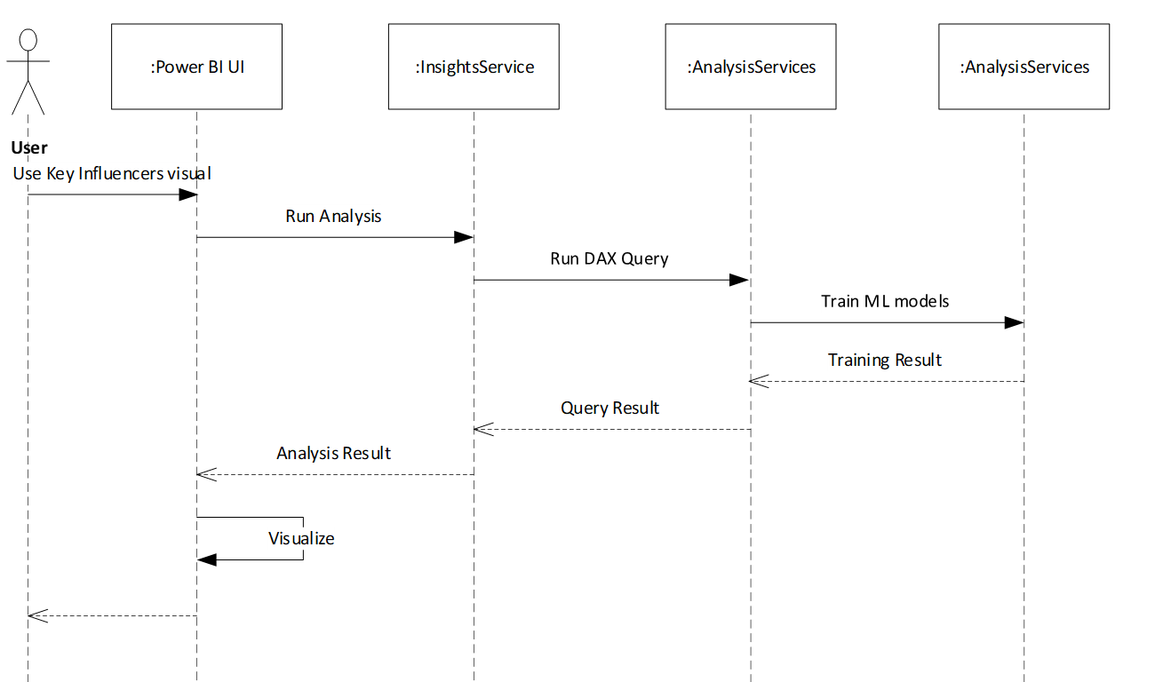
ML.NET is consumed as a .NET Framework library and runs either on-premises (if used in Power BI Desktop) or in the cloud (if used in the Power BI service). Datasets in Power BI are stored in a binary format native to Analysis Services.

Categorical variables as key influencers
Categorical metrics can include things like ratings or rankings. In the example below, the metric is Rating, and the visualization has determined that Role in Org is consumer is the top single factor that influences the likelihood of a low rating. The visualization displays additional information in the right pane, such as:
- 14.93% of consumers give a low score.
- On average, all other roles give a low score 5.78% of the time.
- Consumers are 2.57 times more likely to give a low score compared to all other roles.
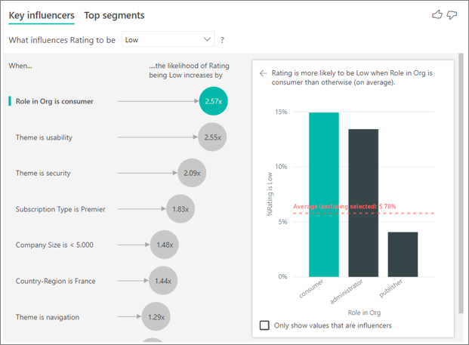

Logistic Regression for Categorical variables in Key Influencers
Key Influencers uses ML.NET to run logistic regression for categorical metrics, using the One-hot encoding, Replace missing value, and Normalize mean variance data transformations and the L-BFGS Logistic Regression algorithm. In this case, the algorithm searches for patterns in the data and looks for how customers who gave a low rating might differ from the customers who gave a high rating. It might find, for example, that customers with more support tickets give a higher percentage of low ratings than customers with few or no support tickets.

Continuous variables as key influencers
Numeric metrics can include things like price or sales numbers. In the example below, the metric is House Price, and the visualization has determined that Kitchen Quality is Excellent is the top single factor that influences the likelihood of an increase in house price.
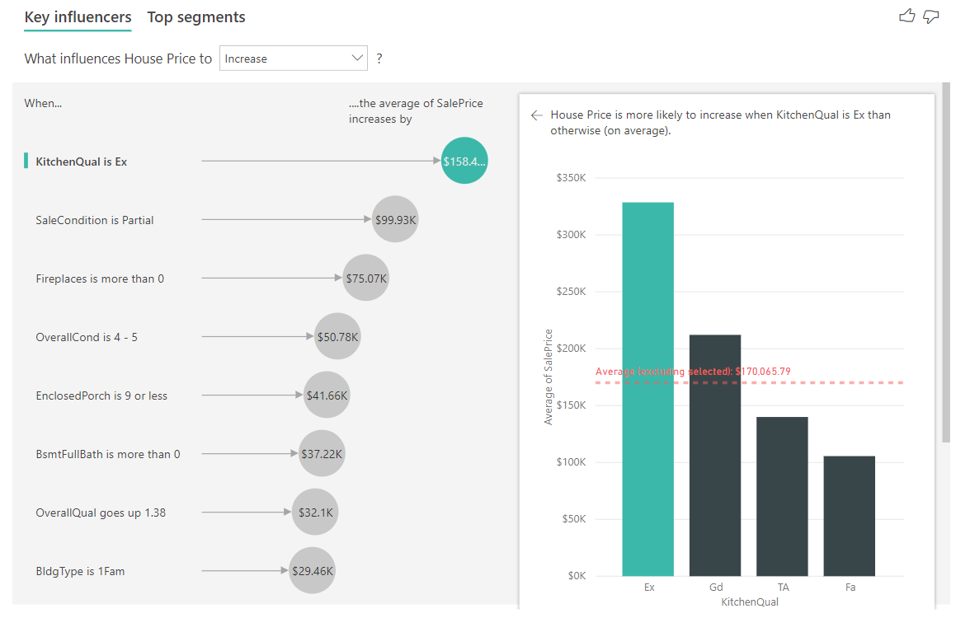

Linear Regression for Continuous variables in Key Influencers
Key Influencers uses ML.NET to run linear regression, using the same data transformations as the categorical key influencers and using the SDCA regression algorithm. In this case, the algorithm looks at how the house price changes based on explanatory factors, such as number of bedrooms or square footage. In this case, it looks at the impact having an excellent kitchen will have on the house price.

Calculating top segments
Top Segments shows the top groups that contribute to the selected metric value. A segment is made up of a combination of values. For example, the segment below is people who are consumers or administrators, who have greater than 4 support tickets, and who have been customers for over 29 months. 74.3% of the customers in this segment gave a low rating, compared to the average customer, which gave a low rating 11.7% of the time.
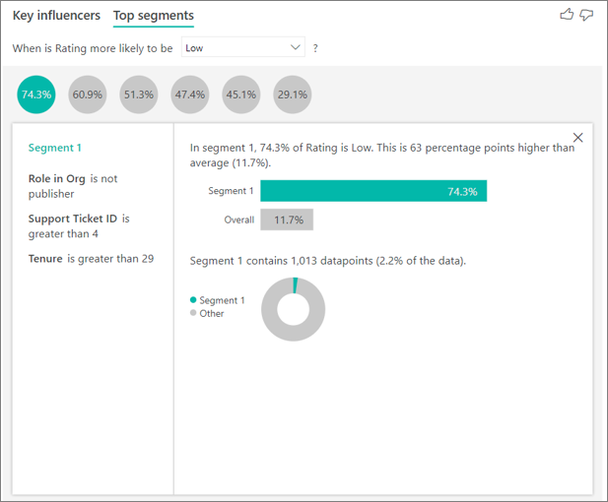

The Fast Tree Decision Trees Algorithm in Key Influencers
Top Segments uses ML.NET to run a decision tree, using Fast tree algorithms (categorical and numerical), to find interesting subgroups. The objective is to end up with a subgroup of data points that's relatively high in the metric of interest. This could be customers with low ratings or houses with high prices.
The algorithm takes each explanatory factor and tries to reason which factor gives it the best split. After the decision tree does a split, it takes the subgroup of data and determines the next best split for that data. In this case, the subgroup is customers who commented on security. After each split, it also considers whether it has enough data points for this group to be representative enough to infer a pattern from or whether it's an anomaly in the data and not a real segment. After the decision tree finishes running, it takes all the splits, such as security comments and large enterprise, and creates segments.
Power BI uses ML.NET so that business customers can easily identify key influencers in their businesses, saving them time and effort and allowing them to focus on making changes and business decisions based on analytics and insights produced from the ML.NET models.
The key influencers visual helps you understand the factors that drive a metric you're interested in. It analyzes your data, ranks the factors that matter, and displays them as key influencers. For example, suppose you want to figure out what influences employee turnover, which is also known as churn. One factor might be employment contract length, and another factor might be commuting time.

When to use key influencers
The key influencers visual is a great choice if you want to:
- See which factors affect the metric being analyzed.
- Contrast the relative importance of these factors. For example, do short-term contracts affect churn more than long-term contracts?

Features of the key influencers visual
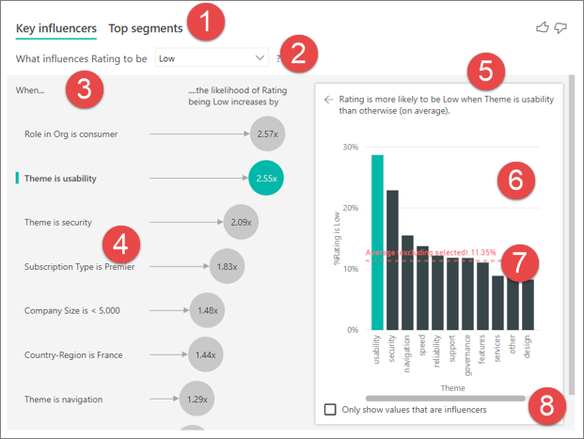
- Tabs: Select a tab to switch between views. Key influencers shows you the top contributors to the selected metric value. Top segments shows you the top segments that contribute to the selected metric value. A segment is made up of a combination of values. For example, one segment might be consumers who have been customers for at least 20 years and live in the west region.
- Drop-down box: The value of the metric under investigation. In this example, look at the metric Rating. The selected value is Low.
- Restatement: It helps you interpret the visual in the left pane.
- Left pane: The left pane contains one visual. In this case, the left pane shows a list of the top key influencers.
- Restatement: It helps you interpret the visual in the right pane.
- Right pane: The right pane contains one visual. In this case, the column chart displays all the values for the key influencer Theme that was selected in the left pane. The specific value of usability from the left pane is shown in green. All the other values for Theme are shown in black.
- Average line: The average is calculated for all possible values for Theme except usability (which is the selected influencer). So the calculation applies to all the values in black. It tells you what percentage of the other Themes had a low rating. In this case 11.35% had a low rating (shown by the dotted line).
- Check box: Filters out the visual in the right pane to only show values that are influencers for that field. In this example, the visual is filtered to display usability, security, and navigation.

START THE LAB HERE

Setup dependent and independent variables – Focus on Categorical variables

Business Goal
Your Product Manager wants you to figure out which factors lead customers to leave negative reviews about your cloud service.

Get the Data
To follow along in Power BI Desktop, open the Customer Feedback PBIX file. This file is available in week 8 folder.

Credits
The Customer Feedback data set is based on [Moro et al., 2014] S. Moro, P. Cortez, and P. Rita. "A Data-Driven Approach to Predict the Success of Bank Telemarketing." Decision Support Systems, Elsevier, 62:22-31, June 2014.

- Open the Customer Feedback PBIX file.
- Under Build visual on the Visualizations pane, select the Key influencers icon.
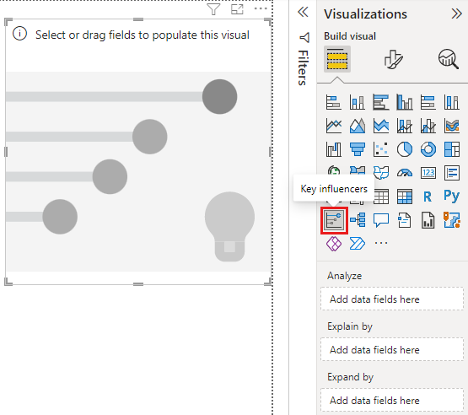
- Move the metric you want to investigate into the Analyze field. To see what drives a customer rating of the service to be low, select Customer Table > Rating.
- Move fields that you think might influence Rating into the Explain by field. You can move as many fields as you want. In this case, start with:
  - Country-Region
  - Role in Org
  - Subscription Type
  - Company Size
  - Theme

- Leave the Expand by field empty. This field is only used when analyzing a measure or summarized field.
- To focus on the negative ratings, at the top of the visual select Low in the What influences Rating to be drop-down box.
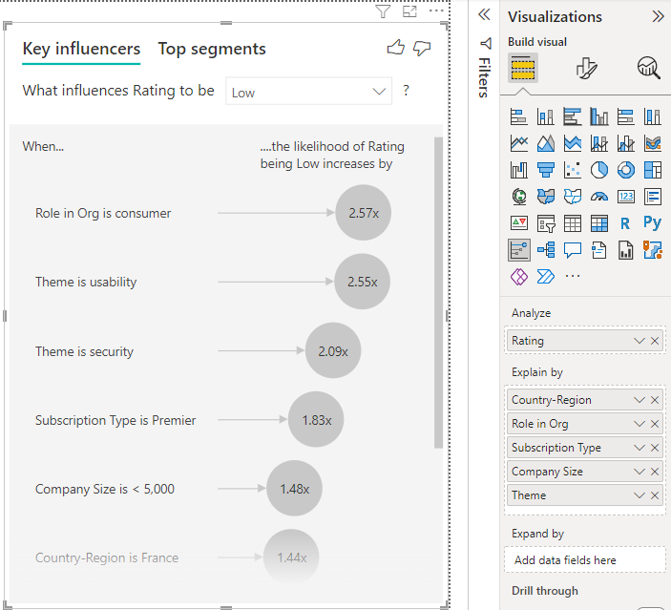
The analysis runs on the table level of the field that's being analyzed. In this case, it's the Rating metric. This metric is defined at a customer level. Each customer has given either a high score or a low score. All the explanatory factors must be defined at the customer level for the visual to make use of them.

Data Modeling and Preparation
Each customer is assigned a single theme to their rating. Similarly, customers come from one country or region, have one membership type, and hold one role in their organization. The explanatory factors are already attributes of a customer, and no transformations are needed. The visual can make immediate use of them.

The effect of the Role variable for customer ratings
The customer in this example can have three roles: consumer, administrator, and publisher. Being a consumer is the top factor that contributes to a low rating.
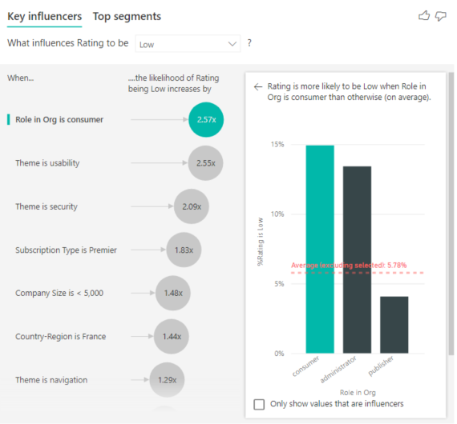
More precisely, your consumers are 2.57 times more likely to give your service a negative score. The key influencers chart lists Role in Org is consumer first in the list on the left. By selecting Role in Org is consumer on the visual, Power BI shows more details in the right pane. The comparative effect of each role on the likelihood of a low rating is shown.
- 14.93% of consumers give a low score.
- On average, all other roles give a low score 5.78% of the time.
- Consumers are 2.57 times more likely to give a low score compared to all other roles. You can determine this score by dividing the green bar by the red dotted line.

The Theme independent variable
The key influencers visual compares and ranks factors from different variables. Select the second influencer in the list, which is Theme is usability.
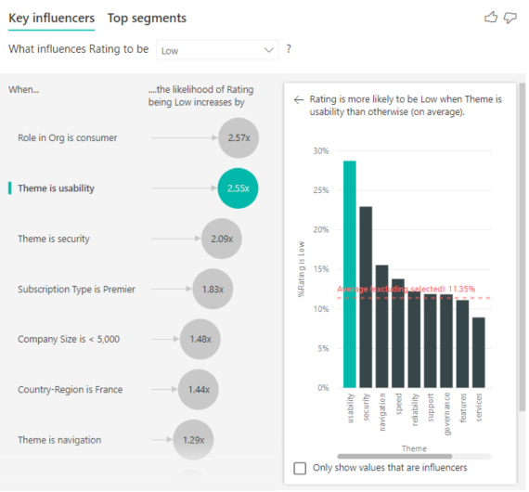
The second most important factor is related to the theme of the customer’s review. Customers who commented about the usability of the product were 2.55 times more likely to give a low score compared to customers who commented on other themes, such as reliability, design, or speed.
Between the visuals, the average, which is shown by the red dotted line, changed from 5.78% to 11.35%. The average is dynamic because it's based on the average of all other values. For the first influencer, the average excluded the customer role. For the second influencer, it excluded the usability theme.
Select the Only show values that are influencers check box to filter by using only the influential values. In this case, they're the roles that drive a low score. 12 themes are reduced to the four that Power BI identified as the themes that drive low ratings.
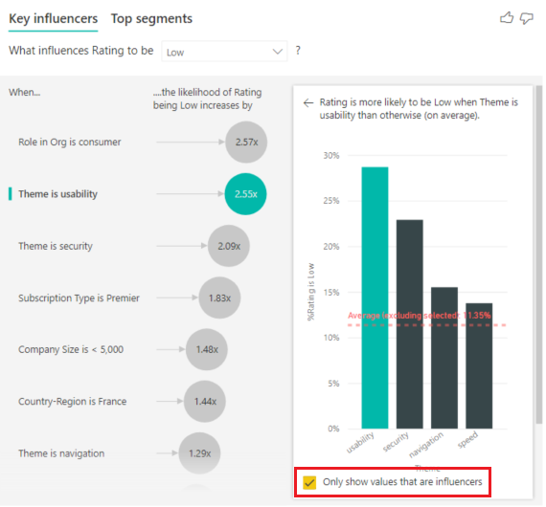

Save your first page of the report - Rating
At the bottom of the Power BI screen, save this page of your report as Categorical Variables.

Continuous variables as Key Influencers – Add Tenure
So far, we have seen how to use the key influencers visual to explore how various categorical variable fields influence low ratings. It's also possible to have continuous variables such as age, height, and price in the Explain by field. Let’s look at what happens with tenure. Tenure depicts how long a customer has used the service.

- At the bottom of the Power BI screen right click on the Categorical Variables page tab and select duplicate to create a new page in this Power BI report. Save this page as "Continuous Variables".
- Move the field Tenure from the Customer table into the Explain by box.
As tenure increases, the likelihood of receiving a lower rating also increases. This trend suggests that the longer-term customers are more likely to give a negative score. Specifically, the visualization shows that if tenure is more than 29 years, the likelihood of a low rating increases by 2.86 times.
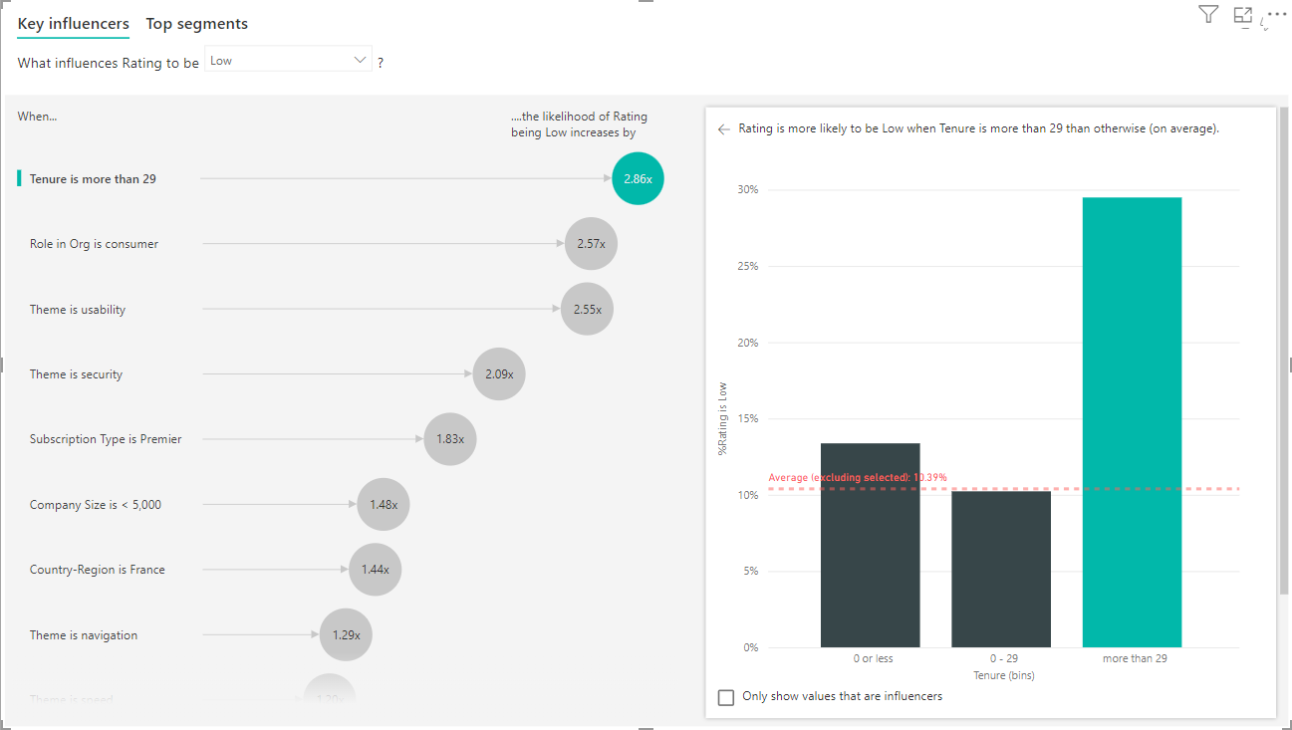

Binned continuous variables as key influencers
In some cases, you may find that your continuous variables were automatically turned into categorical ones. If the relationship between the variables isn't linear, we can't describe the relationship as simply increasing or decreasing (like we did in the example above).
Power BI runs correlation tests to determine how linear the influencer/independent variable is with regard to the dependent variable. If the dependent variable is continuous, Power BI runs a Pearson correlation and if it is categorical, Power BI runs Point Biserial correlation tests. If it detects the relationship isn't sufficiently linear, it conducts supervised binning and generates a maximum of five bins. To figure out which bins make the most sense, it uses a supervised binning method that looks at the relationship between the dependent variable and the independent variable.

- Save your work

Aggregates as independent variables - Add the Support Ticket ID

- At the bottom of the Power BI screen right click on the Continuous Variables page tab and select duplicate to create a new page in this Power BI report. Save this page as Aggregate variables.
We can use aggregates as explanatory factors/independent variables inside your analysis. For example, you might want to see what effect the count() of customer support tickets or the average duration of an open ticket has on the score you receive. In this case, you want to see if the number of support tickets that a customer has influences the score they give.

- Add the Support Ticket ID from the support ticket table to the Explain By area of the visual.

Because a customer can have multiple support tickets, we aggregate this field by customer. Aggregation is important because the analysis runs on the customer level, so all drivers must be defined at that level of granularity.
Let's look at the count of IDs. Each customer row has a count of support tickets associated with it. In this case, as the count of support tickets increases, the likelihood of the rating being low goes up 4.08 times. The visual on the right shows the average number of support tickets by different Rating values evaluated at the customer level.
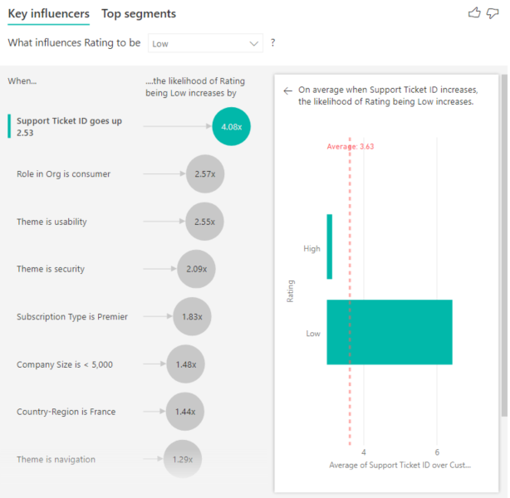

Identify top segments
Up until now we have seen how to use Key influencers to assess each factor individually. We can also use the Top segments tab to see how combinations of factors affect the metric we are analyzing.
Click the top segments tab. Top segments initially show an overview of all the segments that Power BI discovered. The following example shows that six segments were found. In your own lab the segments might be less or more. These segments are ranked by the percentage of low ratings within the segment. Segment 1, for example, has 74.3% customer ratings that are low. The higher the bubble is placed in the chart, the higher the proportion of low ratings. The size of the bubble represents how many customers are within the segment.
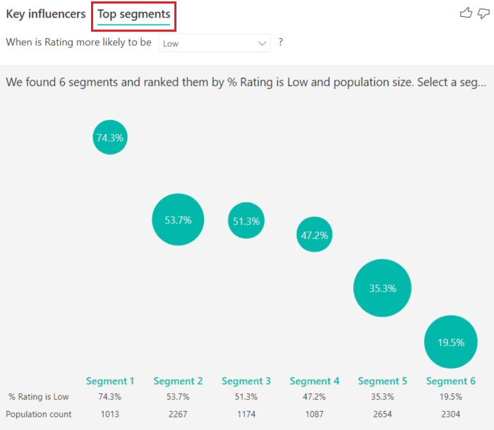
Selecting a bubble displays the details of that segment. If you select Segment 1, for example, you find that it's made up of relatively established customers. They've been customers for over 29 months and have more than four support tickets. Finally, they're not publishers, so they're either consumers or administrators.
In this group, 74.3% of the customers gave a low rating. The average customer gave a low rating 11.7% of the time, so this segment has a larger proportion of low ratings. It's 63 percentage points higher. Segment 1 also contains approximately 2.2% of the data, so it represents an addressable portion of the population.
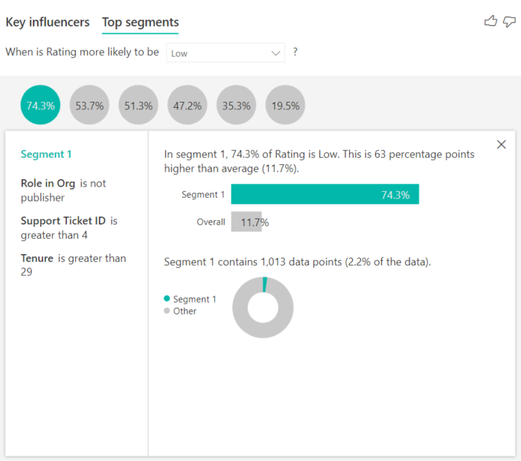

Adding counts
Sometimes an influencer can have a significant effect but represent little of the data. For example, Theme is usability is the third biggest influencer for low ratings. However, there might have only been a handful of customers who complained about usability. Counts can help you prioritize which variables/infuencers you want to focus on.
- Turn on counts through the Analysis card of the formatting pane.
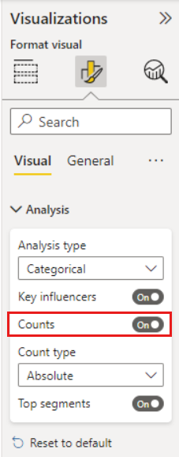

After counts are enabled, you’ll see a ring around each influencer’s bubble, which represents the approximate percentage of data that influencer contains. The more of the bubble the ring circles, the more data it contains. We can see that Theme is usability contains a small proportion of data.
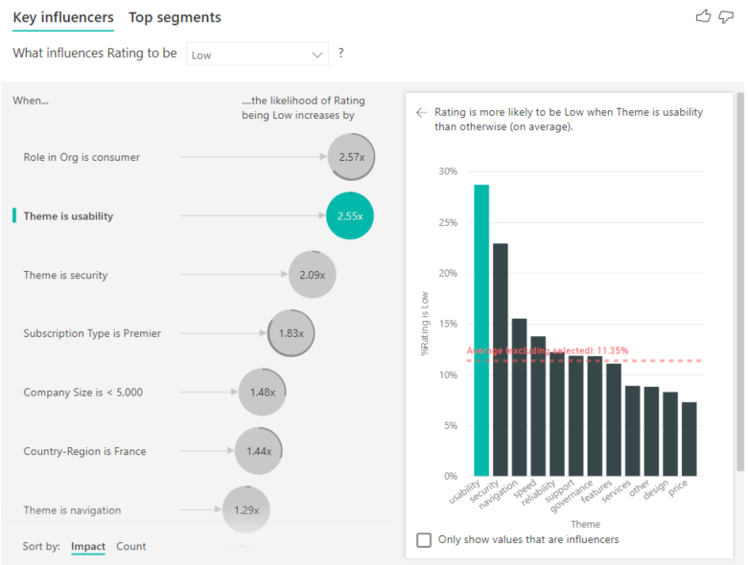
You can also use the Sort by toggle in the bottom left of the visual to sort the bubbles by count first instead of impact. Subscription Type is Premier is the top influencer based on count.
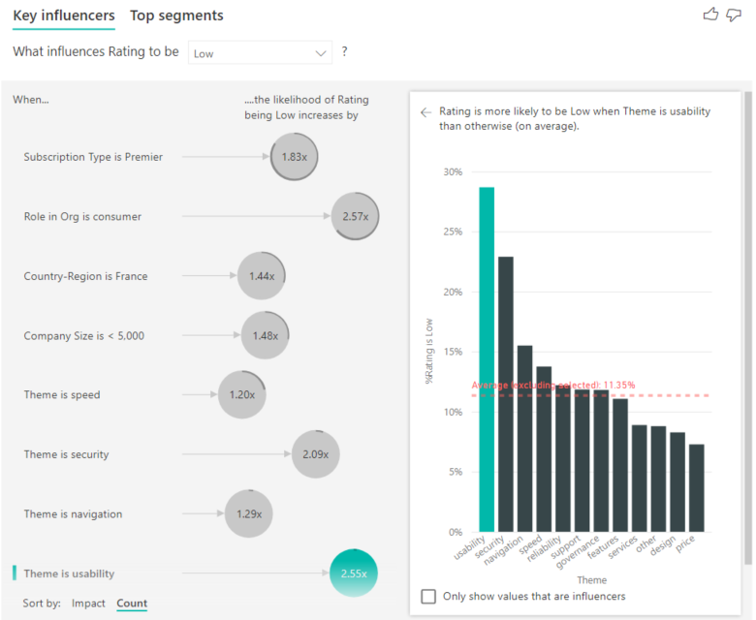
Having a full ring around the circle means the influencer contains 100% of the data.
- Change the count type to be relative to the maximum influencer using the Count type dropdown in the Analysis card of the formatting pane. Now the influencer with the most amount of data will be represented by a full ring and all other counts will be relative to it.
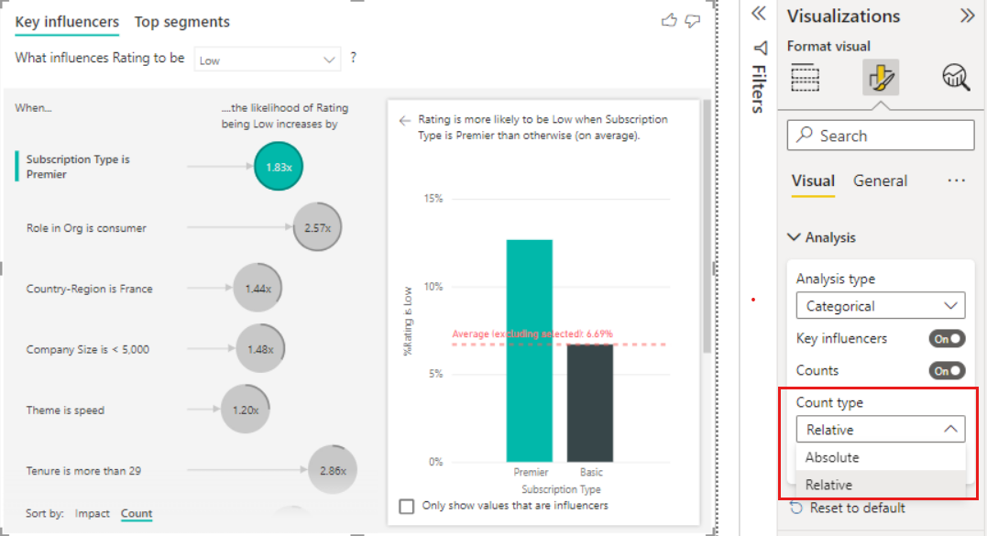

Save Your work
Save your report.

